Resources for Parents and Families
During the Coronavirus Pandemic

With the disruption of our normal day-to-day lives due to the coronavirus pandemic, it is not unexpected that parents and caregivers would feel the effects of stress and anxiety. Caregivers dealing with children have another level of stress added as they try to juggle their household responsibilities, online schooling, and keeping kids occupied during these days of confinement.

We have compiled a list of resources and sites for parents, grandparents and kids to visit to help navigate these previously uncharted waters and perhaps help make our days more productive and less anxiety-provoking.

The American Academy of Pediatrics HealthyChildren.org website has a constantly updated page on the novel coronavirus that covers both the science and practical guidance for parents. Other new articles for parents from the website include:

Working and Learning from Home During the COVID-19 Outbreak

Social Distancing: Why Keeping Your Distance Helps Keep Others Safe

Tips for Coping with a New Baby During COVID-19

Positive Parenting & COVID-19: 10 Tips to Help Keep the Calm at Home

———

EcoWatch: How to Talk to Your Kids About the Coronavirus Outbreak

A series of colorful graphic panels you can use when talking to children can be accessed HERE.

The Center on the Developing Child at Harvard University: Stress, Resilience, and the Role of Science: Responding to the Coronavirus Pandemic

Recommendations from Dr. Harper Keenan, the Robert Quartermain Assistant Professor of Gender & Sexuality Research in Education at the University of British Columbia. What he has to say can be accessed HERE.

Child Trends: Resources for Supporting Children’s Emotional Well-being during the COVID-19 Pandemic
Early Learning Nation: A Parent’s Guide to Surviving COVID-19: 8 Strategies to Keep Children Healthy and Happy
Harvard Graduate School of Education: Helping Children Cope with Coronavirus and Uncertainty
National Association of School Psychologists: Talking to Children About COVID-19 (Coronavirus): A Parent Resource
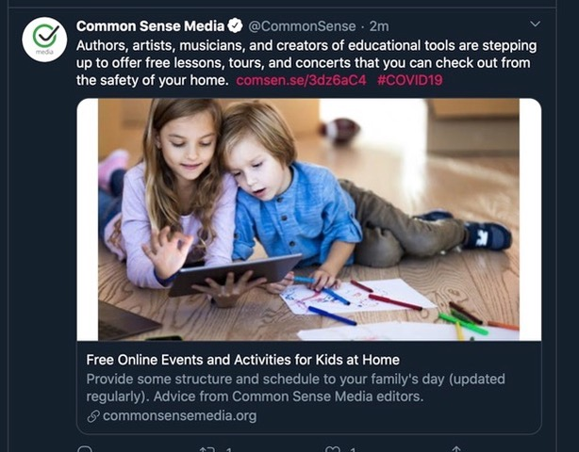
Keep Kids Busy and Learning: CommonSenseMedia.org
Docs For Tots: Apps and Activities to Do at Home

And finally, a video of interest to all of us:

VIDEO: How to Handle Food Safely During the Crisis

Steven J. Goldstein, MD
If you have sites or resources to add to this list, please send them to SJG34@Cornell.edu

